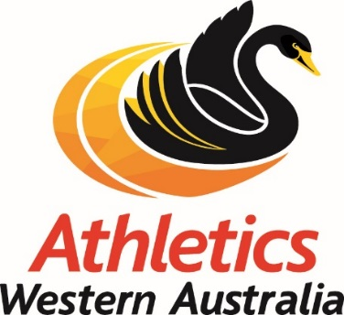

2018 ANNUAL GENERAL MEETING
Elected Director Nomination Form
I,
First name:______________________________
Surname:_____________________________ of
Address:________________________________________________
Phone (H):__________________ Phone (M):___________________
Email:___________________________________________________
Club Name: _____________________________
Registration Number:_____________________
am willing to accept this nomination to be an Elected Director of Athletics Western Australia.

Signature:_________________________________________

Proposing President/Chairperson

Name:____________________________________

Name of Club:
Registration Number:________________________________

Signature:________________________________

Proposing Secretary

Name:____________________________________
Registration Number:_________________________________

Signature:________________________________

Attachment: Statement of background etc.(optional)

1. Nominations must be addressed to the CEO and be received no later than 5pm on 5th September 2018.
2. Nominations must be delivered by hand at the AWA Office or by post to PO Box 157, Floreat WA 6014

